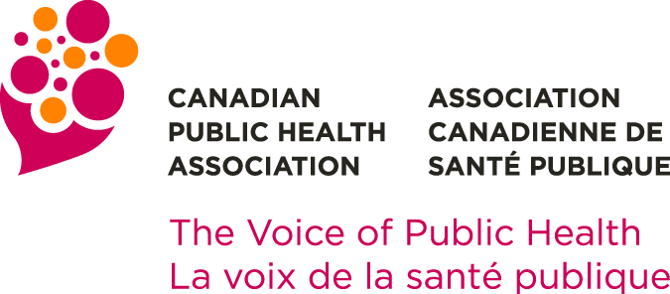 | Board of Directors Election  2021 Student Director Nomination Form

Each Nominee and Nominator must be a CPHA member in good standing.

The nomination form must be accompanied by:
- A statement of eligibility (maximum 500 words, in Word format) from the Nominee indicating how his/her experience fits with the skills and strategic areas being sought by the Nominating Committee; and
- The contact information of the two (2) nominators.

In addition to the above, candidates have the option to include any or all of the following at their discretion:
- Photo (head and shoulders)
- Link to a video message
- Link (one) to an online profile (e.g., LinkedIn)

Nominee

Name of Nominee
Educational Institution
Enrollment Dates
Address
City |  |  |  | Province |  |  | Postal Code
Telephone (daytime) |  |  | Email
 | I hereby acknowledge and give my consent as a Student Director Nominee for the CPHA Board of Directors 2021 Elections

Nominators (2 – one of whom must be a current CPHA student member)

Name of Nominator #1
Address
City |  |  | Province |  |  | Postal Code
Telephone (daytime) |  | Email
CPHA will contact each Nominator to confirm their support of your nomination

Name of Nominator #2
Address
City |  |  | Province |  |  | Postal Code
Telephone (daytime) |  | Email
CPHA will contact each Nominator to confirm their support of your nomination
Nominee’s Statement

Name of Nominee
Please provide a brief statement (maximum 500 words, in MS WORD format).
Candidates are invited to consider the following suggestions in drafting their statement:
- Write in the first person (i.e., I did this, I support that)
- Consider including information in the following categories:
  - Background including education and any relevant work or volunteer experience
  - Interest and any acquired skills related to public health and governance
  - Why you are standing for election and what you hope to achieve as a Student Director
- This statement is your introduction to members who do not know you, so endeavour to represent your personality and interests accurately

Optional link to video message:
Optional link to online profile:
If you choose to include your photograph with your statement, please include it as an attachment when submitting your nomination form.

All nominations must be received by the office of the Executive Director no later than 17:00 (ET) 9 September 2021. Addressed to:
Nominating Committee
Canadian Public Health Association
Email: nominations@cpha.ca

You will receive an email confirmation of receipt of your nomination.

NOMINATIONS RECEIVED AFTER 17:00 (ET) 9 SEPTEMBER 2021
WILL NOT BE CONSIDERED.

