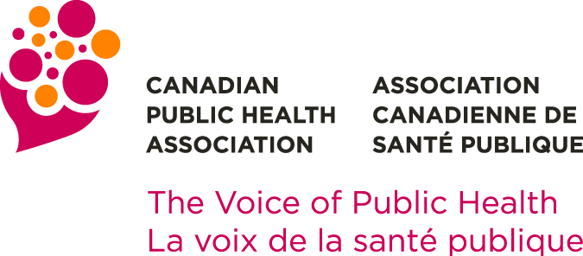 | Board of Directors Election  2022 Nomination Form

Each Nominee and Nominator must be a CPHA member in good standing.

The nomination form must be accompanied by:
- A statement of eligibility (maximum 500 words, in Word format) from the Nominee indicating how his/her experience fits with the skills and strategic areas being sought by the Nominating Committee; and
- The contact information of the two (2) nominators.

In addition to the above, candidates have the option to include any or all of the following at their discretion:
- Photo (head and shoulders)
- Link to a video message
- Link (one) to an online profile (e.g., LinkedIn)

Nominee

Name of Nominee
Address
City |  |  |  | Province |  |  | Postal Code
Telephone (daytime) |  |  | E-mail
 | I hereby acknowledge and give my consent as a Nominee for the CPHA Board of Directors 2022 Elections

Nominator #1

Name of Nominator
Address
City |  |  | Province |  |  | Postal Code
Telephone (daytime) |  | E-mail

CPHA will contact each Nominator to confirm their support of your nomination

Nominator #2

Name of Nominator
Address
City |  |  | Province |  |  | Postal Code
Telephone (daytime) |  | E-mail

CPHA will contact each Nominator to confirm their support of your nomination

Nominee’s Statement

Name of Nominee
Please provide a brief statement (maximum 500 words, in MS WORD format).
Candidates are invited to consider the following suggestions in drafting their statement:
- Write in the first person (i.e., I did this, I support that)
- Consider including information in the following categories:
  - Background including education
  - Relevant work experience
  - Why you are standing for election and what you hope to achieve as a Director
- Clearly identify your qualifications as related to the strategic areas being sought
- This statement is your introduction to members who do not know you, so endeavour to represent your personality and interests accurately
- Questionnaire answers do not have to be lengthy; only two or three sentences are required for each question.

Statement:

Questionnaire: All nominees should complete this short skills assessment questionnaire. Their responses will be reviewed by the Nominating Committee to help ensure that nominees possess sufficient skills to enable them to contribute to the Board’s deliberations. The questionnaire responses will not be published. The Nominating Committee’s recommendations will be reviewed by the Board of Directors that will then make final decisions regarding the eligibility of each nominee. It is possible that a nominee will be disallowed from standing for election. The Board’s decision is final. For additional information regarding this assessment protocol, please contact nominations@cpha.ca.

Optional link to video message:
Optional link to online profile:
If you choose to include your photograph with your statement, please include it as an attachment when submitting your nomination form.

All nominations must be received by the office of the Executive Director no later than 17:00 (ET) 31 August 2022. Addressed to:
Nominating Committee
Canadian Public Health Association
E-mail: nominations@cpha.ca

You will receive an e-mail confirmation of receipt of your nomination.

NOMINATIONS RECEIVED AFTER 17:00 (ET) 31 AUGUST 2022
WILL NOT BE CONSIDERED.

